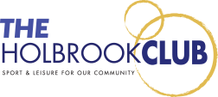

Treasurers report full year to 31 December 2023

I am pleased to present the 2023 financial accounts for the year and happy to confirm that the accountants can confirm that The Holbrook Club is a going concern, is solvent and liquid.

The Club made a net profit of £ 24,721 up from £9,982in the year and this increased the net worth of the club to £78,802 from £54,081.

The net current assets stood at £62,533 up from £32,572 which shows that we are able to meet all our liabilities.

Turnover for the year grew 9.5% and this has enabled us to start carrying out improvements in the Clubs’ infrastructure although we are fully aware that this will take a few years of sustained growth and profitability to complete, but from where we were two years ago we are now able to focus on the positive and make plans. This relies on excellent staff and members continuing to support the increasing number of events that will pay for your club’s improvements.